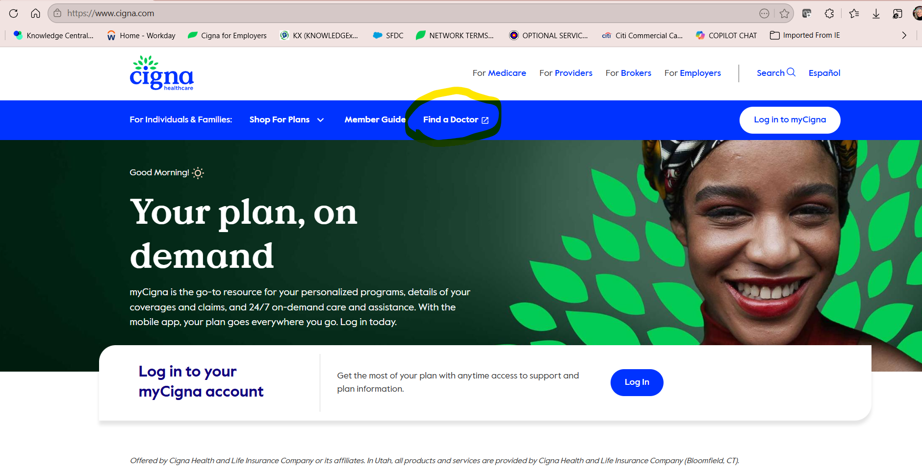

Once you are on the Cigna.com site, customers can
Confidential, unpublished property of The Cigna Group. Do not duplicate or distribute. Use and distribution limited solely to authorized personnel. © 2026 The Cigna Group
- select Find a Doctor

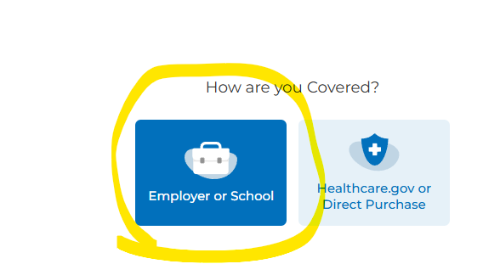

- select Employer or School
Confidential, unpublished property of The Cigna Group. Do not duplicate or distribute. Use and distribution limited solely to authorized personnel. © 2026 The Cigna Group

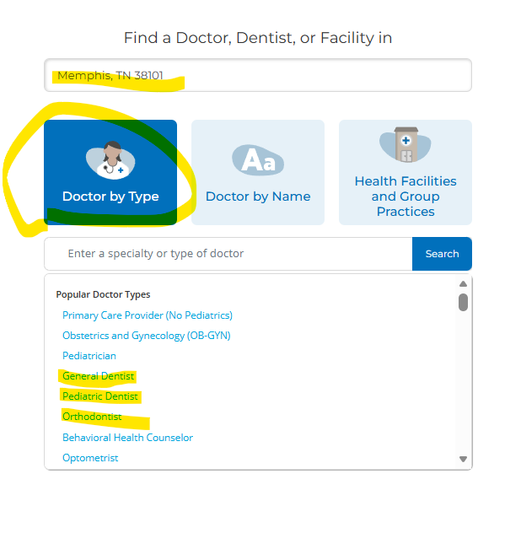
- type in address, city or zip code
Confidential, unpublished property of The Cigna Group. Do not duplicate or distribute. Use and distribution limited solely to authorized personnel. © 2026 The Cigna Group
- select Doctor by Type (this includes dentists)
- select Search

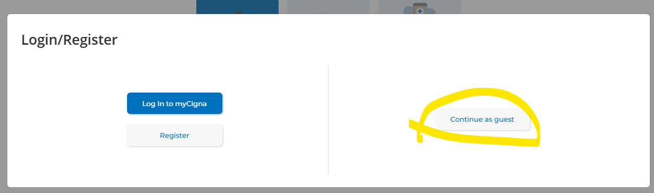

- select Continue as guest
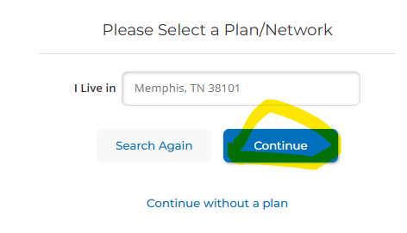
- select Continue

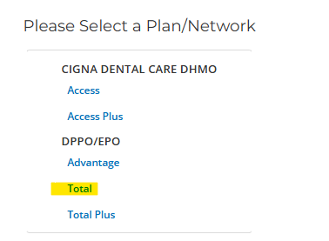

- select Total

The customer will then see all available INN (in-network) dentists in the DPPO Total Network. The customer will also see dentists that are accepting new patients (see example below).
